**SYD466 – Individual Final Assignment**

This assignment documents your part of your group’s proposal to the client.

**Deliverables:**

* A word compatible document for each of your use cases that you’ve been working on this semester
* One .vpp file that contains the diagrams that you’ve developed for your use cases.

For your Simple and Complex use cases, please include:

* User Story
* Activity Diagram
* UI Design
* Use case description documenting ‘add’
* Class diagram
* Sequence diagram

All the work that you’ve copied here from your previous submissions must be improved based on the feedback from the professor and the class discussions in the weeks after your previous labs’ submissions.

As a conclusion, please reflect on your work including the following aspects:

1. What is a use case?
2. What is a use case description/specification? Why do we need to have this?
3. How does UI design help your system design?
4. Describe the relationship between class diagram and sequence diagram?
5. What are your takeaways from learning about designing class diagrams?
6. How will your actors use this functionality in their work?
7. **What is a use case?** A use case is a description of a system's behavior as it responds to a request that originates from outside of that system. Essentially, it specifies the interactions between external actors (which can be users or other systems) and the system itself to achieve a particular goal.
8. **What is a use case description/specification? Why do we need to have this?** A use case description or specification details the functional requirements of a system, outlining the steps taken by an actor to accomplish a specific task or goal within the system. It includes the use case's context, actors, triggers, preconditions, postconditions, basic flow (the normal, expected flow), and alternative flows (handling of errors or exceptions). We need use case specifications to ensure clarity in understanding what the system is supposed to do from an end-user perspective, to communicate requirements, and to serve as a guide for system design.
9. **How does UI design help your system design?** UI (User Interface) design significantly aids system design by providing a clear and intuitive interface for the Assistant Harbour Master to interact with. It ensures that all necessary steps to add a new client for boat slip booking are presented logically, reduces the risk of user error, and streamlines the overall process. An effective UI design can lead to a system that is easy to use, which can enhance user satisfaction and efficiency.
10. **Describe the relationship between class diagram and sequence diagram?** The class diagram and the sequence diagram are both parts of UML (Unified Modeling Language) and serve different purposes in system design. A class diagram describes the static structure of a system by showing the system's classes, their attributes, methods, and the relationships between the classes. On the other hand, a sequence diagram represents the dynamic behavior of a system by showing how objects interact with each other in a particular sequence of time. The sequence diagram illustrates how instances of the classes defined in the class diagram collaborate with each other to perform a function, such as adding a customer in this use case.
11. **What are your takeaways from learning about designing class diagrams?** Designing class diagrams helps in understanding the blueprint of the system. It clarifies how different parts of the system interrelate and depend on each other, defining the internal structure before any actual coding starts. It's a crucial step in object-oriented design, as it helps in identifying the necessary classes, their responsibilities, and relationships, which can greatly impact the maintainability and scalability of the system.
12. **How will your actors use this functionality in their work?** The Assistant Harbour Master, as the actor, will use this functionality to efficiently manage the booking of boat slips. They will use the forms and interfaces to add customer information, select the appropriate booking type, and ensure that the customer is added to the system with all necessary details. The system's design, as depicted in the activity diagram, guides the Assistant Harbour Master through a structured process, from entering customer details to finalizing the booking with an invoice or receipt, thereby facilitating accurate and efficient work. In their work, the Marine Workshop Managers will use the efficient ordering system to: Select vendors from a system-generated list to find the best source for needed parts and supplies. View and choose specific inventory items and their quantities from the selected vendor to ensure the workshop has the necessary materials. Review the cumulative order list, adding or adjusting items as needed before finalizing. Confirm the completion of the order, at which point the system will process it and provide confirmation that the order has been successfully placed.

**Simple Use Case**

**User Story:**

As the Assistant Harbour Master at Round the Bend Marina, I want to implement a system that allows me to efficiently add new clients seeking permanent or one-time boat slips, so that I can streamline the booking process, ensure accurate record-keeping, and improve customer satisfaction.

**Activity Diagram:**

**Adding Client Information Form:**

Clicking on the submit will direct the user to selecting the Booking type. The form is shown below.

**Selecting Booking Type Form:**

Once the user clicks the submit button, the client gets added to the system.

**System Use Case Description:**

|  |  |  |
| --- | --- | --- |
| Use Case Name | Add a Customer looking for boat Receipt | |
| Triggering Event | A new Customer came who wants a parking space for the boat. | |
| Brief Description | The use case enables the Assistant Harbour Mater to add a customer looking for a boat receipt on a permanent or one-time basis. | |
| Actors | Assistant Harbour Master | |
| Related Use Cases |  | |
| Preconditions | The assistant harbour master is logged in and has opened the menu to add the boat receipt customer. | |
| Post Conditions | The customer is added to the system and is allotted the parking space. | |
| Flow of activities | Actor | System |
| 1 | Assistant Harbour Master selects the option to add a new customer. | System presents a form to enter customer details, such as first name, last name, contact information, and booking preferences (permanent or one-time), along with the duration of booking if applicable. |
| 2 | Assistant Harbour Master enters the required details into the system. | System validates the entered information. If the information is valid, the system proceeds to display a list of available boat slips. |
| 3 | Assistant Harbour Master selects the appropriate boat receipt based on the client's needs. | System displays the details of the selected boat receipt, including location, dimensions, utilities available, and pricing. |
| 4 | Assistant Harbour Master confirms the selection and requests to finalize the addition of the customer. | System updates the boat receipt status to occupied for the duration specified, generates a unique customer ID, and links the customer to the selected boat slip. The system also prepares a lease agreement for review. |
| 5 | Assistant Harbour Master reviews the lease agreement, confirms details with the client, and signals approval. | System finalizes the lease agreement, updates the database with the new client and their slip assignment, and generates an invoice or receipt for the booking. |
| 6 | Assistant Harbour Master requests to issue the invoice/receipt to the customer. | System generates and provides the invoice/receipt for the customer. It also sends a confirmation of the booking to the customer’s provided contact information. |
| Exception Conditions | 1. If no boat receipts are available, the system informs the Assistant Harbour Master and offers to put the customer on a waiting list. 2. If there is a system error or data mismatch, the system prompts the Assistant Harbour Master to retry the operation or perform a system check. | |

**Sequence Diagram:**



**Class Diagram:**

**Individual Assignment Part-2**

**Complex Use Case**

**User Story**

As the manager of the Marine Workshop, I want an efficient system for placing orders for supplies and parts, so that I can ensure we have the necessary items to fulfill client orders and maintain our service commitments without any delays.

**UI design**

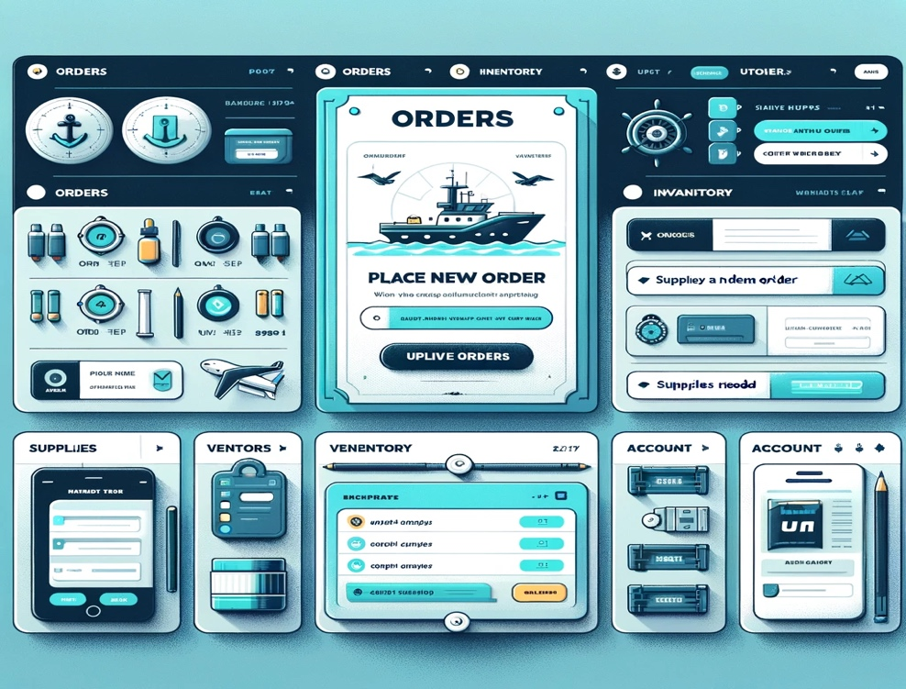

**Activity Diagram**

**Use Case Specification Table**

|  |  |  |  |
| --- | --- | --- | --- |
| Use Case Name | Efficient Ordering System for Marine Workshop Supplies | | |
| Triggering Event | Some items or parts are missing that are required to repair the client boats. | | |
| Brief Description | This use case enables the Marine Workshop manager to place an order for the supplies or items that are required to repair the client boats. | | |
| Actors | Marine Workshop Manager | | |
| Related Use Cases |  | | |
| Preconditions | The Marine Workshop manager is signed in and has opened the menu to place an order. | | |
| Post Conditions | The order is placed. | | |
| Flow of activities | Actor | | System |
|  | 1. | Begins ordering sequence. | Lists potential vendors and prompts for a selection. |
|  | 2. | Selects a vendor from the provided list. | Displays inventory items from the chosen vendor. Requests item selection and quantity input. |
|  | 3. | Chooses inventory items and indicates quantities. | Validates input and aggregates the items to the purchase list. |
|  | 4. | Continues to add more items as necessary. | Refreshes and presents the updated tally of the order. |
|  | 5. | Signals order completion and seeks to confirm. | Processes the order, acknowledges receipt, and provides confirmation of successful placement. |
| Exception Conditions |  | | |

**Class Diagram:**

**Sequence Diagram**

